- Low-PHY Framer block is the subsystem of 1588v2 timing synchronization subsystem (PL part)
- ru_Framer_rtc_subsystem is the sub module of ru framer ip.
- ru framer subsystem contains the following submodules.
- ru framer ctrl timer module
- ru framer int_rtc module
- ru framer dline reg
ru_framer_ctrl_timer_module: In this Module reference next frame, reference next slot, exception double next frame are the generated outputs from the inputs as external systime nano sec field, external systime sec field, external systime one pps, internal systime nano sec field, internal systime sec field, internal systime one pps.
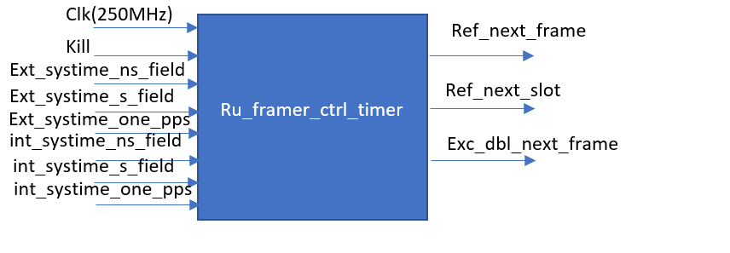
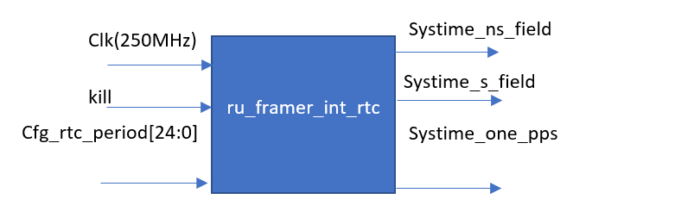
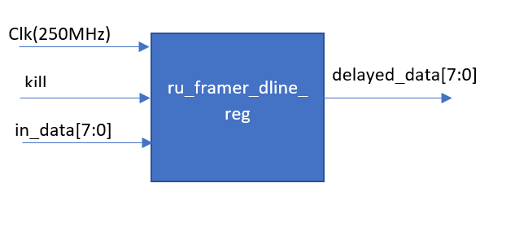

BEAMER SUBSYSTEM
Fig: Beamer Subsystem
The Beamer blocks functionality includes:
- Performing beamforming matrix application (matrix multiplication calculation) for the DL samples, UL samples and UL PRACH samples respectively.
- In the UL, PRACH and SRS blocks performing the sample buffering and timing synchronization before sending them to the O-RAN Subsystem input ports as described in Section 3.3.
- In the DL block performing proper sample and OFDM symbol labelling as described in Section 3.3.
- In SRS Extractor performing SRS subcarriers extraction and routing towards the O-RAN subsystem input.
- For all blocks: providing a logical interface between the O-RAN Interface Subsystem and the other blocks of the LowPHY design including the beam cache and beam index control, PRACH and SRS location control, etc.
All blocks are controlled by the Linux driver via the AXI4-Lite register spaces.
The matrix multipliers perform an 8x8 matrix multiplication to transform 8 O-RAN streams (extended antenna-carriers) to 8 antenna signals or vice versa. The matrix multipliers support the OBW of 200 MHz and 1-8 component carriers within OBW.
As the block is a part of the 122.88 x 3 MHz clock domain, the multiplier includes 8x8x2 scalar complex multipliers utilizing a single DSP block and 3 clock cycles to compute each complex multiplication. Two layers of the 8x8 matrix multipliers are used to process different samples of the 200 MHz OBW. Input and output samples are distributed between the two layers in the sample-by-sample manner, i.e., the even and odd samples of each carrier and each frame are processed by different processing layers.
Processing of samples belonging to different carriers is time-divided in the OFDM symbol-by-symbol manner and performed by the same physical multiplier hardware. The order of OFDM symbols is the carrier index first, the time-domain index of an OFDM symbol second. For combination of different numerologies, the order of OFDM symbols corresponds to the order of symbols in the O-RAN Interface Subsystem (TBD) w/o additional buffering and reordering.
The output data interface of the DL Beamer (and the input data interfaces of the UL Beamer, PRACH Beamer and SRS Extractor) blocks comprises 8 parallel AXI4-Stream interfaces associated with 8 TX/RX antennas. The even and odd samples processed by different matrix multiplier layers are combined to a single AXI4-Stream bus. The flow control (tvalid, tready) is present and the OFDM symbol boundaries and numbers are indicated by a tuser signal.

Beamer Subsystem comprising DL Beamer, UL Beamer, PRACH Beamer and SRS Extractor. The subsystem performs interfacing between other Low-PHY subsystems and the ORAN Radio Interface Subsystem and the TX/RX beamforming functionality (except for SRS Extractor).
Downlink beamer is used for beamforming spatial streams from ORAN IP to antenna port streams with converting output data to the proper format suitable for transmitting to OFDM modulator. DSPU provides input interface of DL Beamer that converts ORAN IP De framer output data to the suitable format for DL Beamer MAC Core. ORAN data processing for one OFDM symbol includes IQ-samples pre-processing, full buffering for data reordering and jitter removal with zero samples insertion for non-scheduled PRBs, clock domain crossing between ORAN and PHY reference clocks. Beamer MAC Core is responsible for 8x8 matrix multiplication to transform 8 spatial streams (extended antenna-carriers) to 8 antenna signals. As the block is a part of the 122.88 x 3 MHz clock domain, the multiplier includes 8x8 scalar complex multipliers. Then products of complex multiplication are summed by adder tree that are also designed via DSP48E2 block.
DL Beamer subsystem includes following modules with corresponded functionality:
- Frame Control – timing and rate control logic according to configured frame parameters and OFDM readiness
- DL DSPU – input interfaces for ORAN spatial streams that are responsible for buffering reordering and data format converting
- TX DMA Signal Generator – input interfaces of test signal stored in PS DDR and used for debug purposes
- DL Beamer MAC Core – core unit of signal beamforming
- Sample converter – MAC Output converter to the target Aurora AXIS format
- AXIS FIFO – output FIFO module to provide AXI4-Stream interface. FIFO depth are selected correspondently to the latency of DL Beam MAC Core.
DSPU module includes following modules with corresponded functionality:
- CDC Two-Segment BID Buffer – a ping-pong buffer for clock domain crossing of BID messages from ORAN IP
- WR Symbol Controller – control of input data writing to Data buffer
- RD Symbol Controller – control of symbol data reading according to requests from Frame control
- udHeader Shifter – debug module that removes udCompHdr field from each input AXI4-Stream transactions
- IQ Byte Swapping – swapping of most significant and least significant bytes of each subcarrier component
- Modulation Decompression (optional) – module of the signal decompression according to the parameters transmitted in Sections Ext4/Ext5
- CDC Two-Segment Data Buffer – ping-pong data buffer with the size of two OFDM symbols
- AXIS FIFO – small FIFO for output AXI4-Stream interface providing
Data buffer is a key component of the DSPU that is implemented via asynchronous true dual-port RAM and different write and read data widths. Input data width is 64 bits, and two SS subcarrier samples are written in one clock cycle that corresponds to ORAN IP output data. Buffer output data width is 32 bits that allows to read one SS subcarrier sample per one clock cycle.
An address space of Data buffer is split into two equal segments with the size of 16 Kbyte per one which allow to store data of one OFDM symbol with the length of 3276 IQ samples. One segment of the buffer is divided into cells with the size of 12 IQ samples that corresponds to one PRB. AXI4-stream transaction of ORAN IP provides information via tuser signal about PRB resources that are scheduled and used for transmission of the current samples from tdata. This information is used by WR Symbol Controller and SS data are written to the corresponded PRB cells only. Cells of non-scheduled PRBs stores zero data values. Zero insertion is implemented jointly with read operations for hardware logic simplification. Each element of data buffer is nulled after its reading. So WR Symbol Controller does not bother about unused resource elements and writes only allocated PRB data. Figure 6 demonstrates ORAN DL signal placement. Allocated PRBs are depicted by solid fill and non-allocated PRBs has stroked fill.

The architecture of DL Beamer MAC core includes following components:
- DL Beam CMAC – complex multipliers with post-adder functionality that is implemented the first round of summation for multiplication results
- DL Beam Adder – adder tree that is implemented rest rounds of summation for multiplication results
- RT Beam Weight Processor – parser of beam vectors that are transmitted via O-RAN protocol
- Beam Cache – two-port addressable memory that stores beam weight vectors
Beamforming procedure per each antenna is performed by Beam CMAC and Beam Adder modules. Therefore, DL Beamer MAC core includes 8 instances of each module according to the number of antenna ports. Number of beam cache instances is equal to the number of spatial streams because different beam vectors can be applied between different SS for the same PRBs.
U-Plane IQ data including user data, PRACH and control channels may be transmitted in compressed format. C-Plane (control plane) is a frame format that carries data used in control user data scheduling, beamforming weight selection, numerology selection, etc. The U-Plane (user plane) is a frame format that carries the user data messages between O-DU and O-RU, such as the in-phase and quadrature-phase (IQ) sample sequence of the orthogonal frequency division multiplexing (OFDM) signal.
The scheme of loading beam weight vector coefficients is presented here. One beam weight vector consists of 8 coefficients that must be read from Beam cache and set to input of the corresponded complex multiplier at a certain point in time. 16 registers are used for those purposes. 8 PRE_FF registers are connected in a daisy chain. for coefficients loading simplification. Input port of the first PRE_FF 0 register is connected to Beam Cache output. Input ports of the PRE_FF (N) registers are connected to the output of the previous PRE_FF (N-1) in the chain, where N > 0. So, loading of 8 beam weight coefficients takes at least 8 clock cycles. 8 BW_FF registers are connected to PRE_FF flip-flops and updates their value on bw_upd signal.
In this MAC emulator, along with IQ data inputs and output data streams, output data stream mux’s created. The MAC data inputs are given to pi/2 phase rotation emulation process. In this process, data inputs are loaded into data stream mux’s with phase rotation method. After that using delay line register module, data output stream mux’s loaded into output data stream signals.

